##### 

| Course Title | Introduction to Engineering |
| --- | --- |
| Course Code | CEN 100 |
| Semester/Year | Fall 2021 |
| Section Number | 29 |
| Group Number | 84 |
| GA & PM | Shereen Al Tamimi & Suhasee Patel |

| **Reverse Engineering Final Report**  THE SAFE TAXI | |
| --- | --- |

| Submission Date | November 24, 2021 |
| --- | --- |

| Student Name | Student ID | Signature* |
| --- | --- | --- |
| Emmily Tse | 501100836 |  |
| Joaquin Katoka | 501104688 |  |
| Luxsika Sinnarasa | 501105669 |  |
| Adrian Parungao | 501102077 |  |
| Kartike Chaudhari | 501118313 |  |
| Tejveer Goga | 501088306 |  |
| Bilal Asghar | 501113295 |  |
| Evan Fekete | 501122435 |  |
| Hamza Ejaz Malik | 501112545 |  |

*\*By signing above you attest that you have contributed to this submission and confirm that all work you have contributed to this submission is your own work. Any suspicion of copying or plagiarism in this work will result in an investigation of Academic Misconduct and may result in a “0” on the work, an “F” in the course, or possibly more severe penalties, as well as a Disciplinary Notice on your academic record under the Student Code of Academic Conduct, which can be found online at:* [*http://www.ryerson.ca/senate/policies/pol60.pdf*](http://www.ryerson.ca/senate/policies/pol60.pdf)*.*

**Abstract**

For many people Taxis are an essential part of life, allowing for people who do have access to their own vehicle the ability to conveniently travel extremely easily and safely. However, the taxi industry pays little attention to the safety of its passengers. Passengers are not protected from diseases brought by passengers before them, and with the ongoing Covid-19 pandemic this issue has only gotten worse. This unhygienic system needs to change in order for us to be able to recover from this pandemic. The team at “Safe Taxi” is designing a new type of taxi with the main purpose is to prevent the spread of germs and bacteria for the people taking the taxi. The way that the team at Safe Taxi is planning on doing this is by using normal taxis as a base and adding new devices and functionalities to it in order to make it more Covid-19 friendly, some of these new devices and functions are: contactless pay, replaceable seats, a dual ventilation system, along with devices that check for vaccination status, and temperature. The goal of this report is to explore why taxis are not suited for the Covid-19 pandemic, along with what our new design is and why it is an improvement, as well as how our product performs under certain criteria, along with going into detail about the three iterations we made leading up to the final design, and finally a piece of marketing that we came up with for the product.

**Introduction**

In today’s world, taxis and ubers are a necessary part of existence. It allows people to travel long distances with ease and convenience. A big percentage of the population, usually teenagers and young adults, do not have access to their own personal vehicles. Therefore, this serves as a rapid and convenient mode of transportation. They also serve the objective of reducing carbon emissions and traffic by reducing the number of cars on the road. The main problem that we are facing with ride-hailing vehicles are that they are not COVID-19 ideal. Especially since there is an ongoing pandemic, proper precautions are not taken by the taxi and uber companies, which provide approximately 4 million rides a day to customers. This could result in cases rising at an exponential rate. This is due to the fact that these vehicles have not been developed to deal with the COVID-19 pandemic nor have strict protocols in place.

The average automobile space is about a tenth of the size of a bedroom. For reference, a study conducted by NetQuote found that the average taxi contains 27,000 colony-forming units per square inch. This creates a large risk for passengers and cab drivers as they will be in contact with large amounts of germs and bacteria during each ride. This study clearly shows that the taxi industry needs a change or remodel for the future, especially since we are in a pandemic ourselves.

It is incredibly simple to spread the virus because only one passenger with the virus is required to infect many others who come into contact. When an infected passenger sneezes, coughs or talks at the most they can transmit the disease through respiratory droplets or aerosols. The aerosols are known to linger in closed spaces and sit on surfaces. Therefore, when the next customer rides in the unsanitized uber or taxi and unknowingly touches the infected surfaces, they could contract COVID-19 from touching their mouth, nose or eyes. COVID-19 can and has been spreading from public transportation, including taxis, according to the SAGE Environmental and Modelling group. After investigating further, it was found that drivers were riding with unmasked customers as well as some drivers were too lazy to sanitize the inside of their vehicles after every ride. Public Health Ontario also discovered that public transportation in Toronto plummeted by 71% from March 8th to March 30th 2020, indicating that the public want a safer alternative.

**Background**

Taxi’s/Uber’s are an essential aspect of society, it provides a means of transportation for the people. But due to Covid-19 the Taxi/Uber industry is dying down and has become very unsafe. Covid can be spread through the air particles we breath and through touch. The goal of our team is to reverse engineer the cars used in this industry and make them move Covid-19 safe and efficient car. The product’s function is to prevent touch and block bacteria in order to promote safety of the driver and passengers against Covid-19.The first motorized taxis were vehicles electrically powered, first making appearances in the streets of Europe and The United States in the late 1890s going into the 1900s. However, combustion powered taxis equipped with taximeters first made its appearance in 1907 and have dominated the design and market ever since. Now the idea of taxis was further adapted by large gross companies such as Uber and Lyft. Uber first launched in 2009 by two brilliant entrepreneurs known as Travis Kalanick and Garrett Camp. What started as an idea just a couple months prior now had turned into a service where customers could find a ride just with the tap of a button. The first ever Uber trip was requested on July 5, 2010. Ever since then, it has been nothing but a positive, upward trend for the company. In 2011, Uber announced its international launch, expanding to countries all over the world. From 2014 until 2019, Uber’s annual revenue grew from 0.4 billion dollars a year to the highest it's ever been at 14.1 million dollars a year. Now, in the first quarter of 2020, Uber’s revenue seemed to be increasing at a much faster rate than its previous years, but in the second quarter of the year, it all took a collapse once a global pandemic was announced and the entire world entered lockdown. To put this in perspective, Uber’s revenue for the first quarter of 2020 was 3.25 billion dollars and in the second quarter was 1.91 billion dollars. Ever since the pandemic, Uber’s revenue has taken a drastic hit.

Our taxis have been designed in order to completely keep the clients safe, but regulations still have to be followed. For the drivers, they must be fully vaccinated in order to be eligible to work. A daily screening assessment must be completed before the work shift. A mask must be worn at all times while passengers are in the vehicle. For the passengers, they have to be fully vaccinated in order to use the service. A screening assessment will have to be completed as well as a temperature check and a confirmation of a fully vaccinated status which will be done by the driver. A mask must be worn throughout the duration of the ride. Passengers must be aware of the safety guidelines and are to be responsible for all of their personal belongings.

The design features in the product include a polycarbonate divider installed between the front and back seats to reduce any sort of contact between the passengers and drivers. Separate ventilation systems for the AC/Heating unit along with HEPA filters to provide clean, bacteria-free air for both the driver and passengers. A scanning device that scans passengers' vaccine passports to identify their vaccination status, and if it is confirmed that the passenger is fully vaccinated, only then will they be allowed to enter. A temperature check is also conducted during this process. For payment, a contactless payment feature is available where passengers can pay for the service through the app to avoid any sort of contact. More detailed information is available in the iteration section of the report.

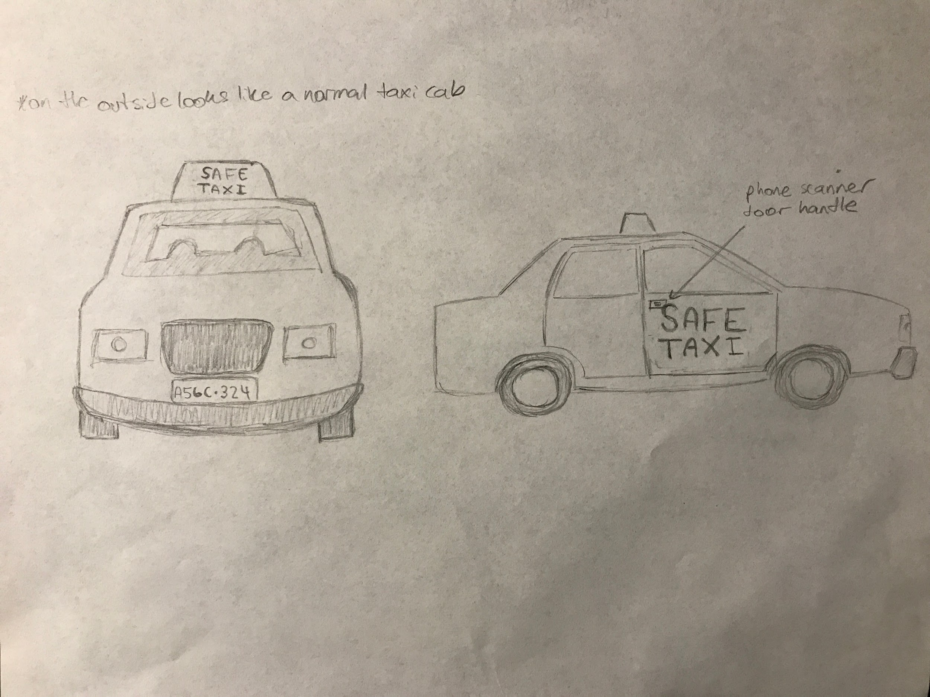

Figure 1: Sketch for the outside view of our Safe Taxi

**Evaluation**

The design team at Safe Taxi puts great emphasis on quality and ensuring that the products made are of high quality. As such they used eight qualities to evaluate the quality of the Safe Taxi in comparison to other taxis. Those qualities being Durability, Sustainability, User Experience, Accessibility, Profitability, Affordability, Performance, and Public Good.

Starting with Durability research showed regular taxis are fairly durable being designed with safety in mind to begin with. As for the first iteration of the Safe Taxi, generally the vehicle remained very durable and safe, however testing showed that the clear vinyl passenger-driver shield was weak and flimsy. In the second iteration the team replaced the clear vinyl shield with one made of polycarbonate, which is significantly stronger thus increasing the durability, however the team also replaced the previously plastic replaceable seat coverings with new paper coverings which are less durable, this decision was made to sacrifice Durability to reduce our carbon footprint since the seats can be recycled. The third iteration did not add anything that would affect the Durability, keeping that aspect the same from the last iteration.

Moving on to Sustainability, testing showed that traditional taxis are able to last as long as regular cars, which have a mileage of around 200000 miles, and since Taxis typically drive 70000 miles per year, taxis are said to last around 3 years. It should also be mentioned that most parts in vehicles can and are recycled. Since our iterations did not add anything to change the vehicle itself the Safe Taxi has a similar lifespan to regular taxis. For the first iteration, the contactless pay, contactless door, and UV lights, were designed in-house by the Safe Taxi team and built to last as long as possible. However, the first version of the replaceable seats ran into issues of getting damaged through daily usage, and constantly requiring to be cleaned, in a similar fashion the driver shield also was found to be very flimsy and would need to be replaced frequently, this was an issue as plastics are not as biodegradable, or as easily recycled as other materials. In the second iteration the design team made sure to fix the issues with the previous design by replacing the plastic seat covers with paper covers, this was done to make it so that the covers one time usage so that damage over time would not matter, also allowing the covers to be recycled. Also changed was the shield between the passenger and the driver now being made of polycarbonate, a much more strong and long lasting material. Finally with the third iteration nothing added or changed affected the sustainability in any way.

Regular Taxis provide a simple user experience, but do currently do not take the pandemic into account, the “Safe Taxi” was designed to keep the functionality of a regular taxicab while being able to reduce the threat of the transmission of Covid-19, as such the user experience was considered in each iteration of the design. In the first iteration, implementations to the base design of a taxi were added to increase the Covid safety of the user. The contactless pay, automatic door, replaceable seats, passenger shield, and UV lights were all instated to make the passengers and drivers feel comfortable while riding in the cab by reducing the amount of contact between them as well as previous passengers. The major improvements for the second iteration on user experience was the implementation of a two-way communication set of speakers and microphones that would allow the passengers and the driver to communicate with each other making the passengers less alienated from the driver. The third and final iteration of the “Safe Taxi” sought to keep the luxuries of the regular car or cab. The third iteration added a HEPA filter to the ventilation system of the car which would help clean the air before reaching the occupants inside, as well as a dual ventilation system to separate the air from the driver with the air from the passenger, to further reduce the stress of any passenger in the Safe Taxi.

The design team of Safe Taxi wanted to make the product safe and accessible to as many people as possible. For each iteration of the cab the accessibility roughly remained the same such that, anyone with access to a mobile device, is fully vaccinated, and has a form of contactless pay would be able to use the “Safe Taxi”. Due to the levels of protection from Covid incorporated into the design of the “Safe Taxi”, it would even be able to cater towards the elderly (65+) and those with medical conditions that could cause their hospitalization if they caught Covid. Overall the “Safe Taxi” was designed to create a safer form of transportation for those who do not have the option of personal transportation.

Only an estimate of the total expense to manufacture the “Safe Taxi” could be given based on several assumptions. The estimated cost was calculated based on the following assumptions, all prior engineering and custom parts have already been designed, and the MSRP of the related product is representative of the material and manufacturing cost of the related Design.

| Related Design | Product used for Estimation | Estimated Cost |
| --- | --- | --- |
| Base taxi | Toyota Corolla [ref] | $19450.0 |
| Plastic sheet chair cover | Cellophane wrap 30`x100`` (*4 )[ref] | $40.0 |
| Contactless pay machine | Apple “Square Reader”[ref] | $60.0 |
| Vaccine checking and Temperature sensor device | MLX90614 infrared temperature sensor [ref]  Sparkfun 2D barcode scanner [ref] | $90.0 |
| UV cabin light | Far UVC 222 nm lamp [ref] | $100.0 |
| Driver and passenger divider | 40 Gauge Clear Vinyl (9 yards) [ref] | $20.00 |
| Automatic door | NEMA 23 servo motor [ref] | $160.0 |
|  | TOTAL: | $19920 |

Table 1.1: Estimate cost to manufacture the “Safe Taxi” iteration 1

| Related Design | Product used for Estimation | Estimated Cost |
| --- | --- | --- |
| Base taxi | Toyota Corolla [ref] | $19450.0 |
| Driver and passenger divider | 4x8 Polycarbonate sheet[ref] | $60.0 |
| Contactless pay machine | Apple “Square Reader”[ref] | $60.0 |
| Vaccine checking and Temperature sensor device | MLX90614 infrared temperature sensor [ref]  Sparkfun 2D barcode scanner [ref] | $90.0 |
| UV cabin light | Far UVC 222 nm lamp [ref] | $100.0 |
| Paper sheet chair cover | Medical Exam table paper [ref] | $10.0 |
| Automatic door | NEMA 23 servo motor [ref] | $160.0 |
|  | TOTAL: | $19910 |

Table 1.2: Estimate cost to manufacture the “Safe Taxi” iteration 2

| Related Design | Product used for Estimation | Estimated Cost |
| --- | --- | --- |
| Base taxi | Toyota Corolla [ref] | $19450.0 |
| Driver and passenger divider | 4x8 Polycarbonate sheet[ref] | $60.0 |
| Contactless pay machine | Apple “Square Reader”[ref] | $60.0 |
| Vaccine checking and Temperature sensor device | MLX90614 infrared temperature sensor [ref]  Sparkfun 2D barcode scanner [ref] | $90.0 |
| UV cabin light | Far UVC 222 nm lamp [ref] | $100.0 |
| Paper sheet chair cover | Medical Exam table paper [ref] | $10.0 |
| Automatic door | NEMA 23 servo motor [ref] | $160.0 |
| HEPA filter for ventilation system | HEPA filter replacement [ref] | $10.0 |
| Provided Covid-19 safety items | Surgical mask[ref] and nitrile gloves [ref] | $30.0 |
|  | TOTAL: | $19970 |

Table 1.3: Estimate cost to manufacture the “Safe Taxi” iteration 3

From the tables above the costs of iteration 1, iteration 2, and iteration 3 respectively total to around $19920, $19910, and $19970. Anyone with the money available to purchase the “Safe Taxi” would be able to, however, the manufacturer would be able to make the most revenue from the “Safe Taxi” from two major types of clients, taxi cab companies and individuals working for transportation services like “Uber” and “Lyft”. Regular taxi services could purchase the “Safe Taxi” in bulk to increase the size of their fleet and increase their commitment to Covid safety, and the “Safe Taxi” could appeal to transportation service drivers that want to protect themselves and their passengers while working.

Throughout the entire design process, the SafeTaxi has prioritized keeping passengers safe from Covid as efficiently and effectively as possible. Thus, all three iterations sought to implement features that would boost the Taxi’s overall performance. As Covid-19 is easily transmitted through direct contact, the first iteration implemented features such as automatic doors, contactless pay, and disposable seat covers to reduce the amount of contact passengers made with the Taxi. The second iteration improved many features relating to passenger safety. The team opted to change the passenger shield material to polycarbonate, as it is a common barrier material and studies have shown it to be effective when used with masks [9]. A passenger shield made out of clear vinyl was also included and UV disinfectant devices were implemented as studies have shown UV light is an effective disinfectant [10]. The seat covering material was also changed from plastic to thin paper. Since paper is recyclable, it was found to be a nice way to reduce the Taxi’s carbon footprint while still retaining the original effectiveness. The third iteration sought to further improve the Taxi’s performance. Thus, a dual ventilation system and HEPA filters were included to ensure the air inside the taxi is clean for passengers.

Finally, speaking about Public Good. Taxis are undeniably an essential part of life for many people, primarily due to the fact that most people are not able to afford their own vehicle to drive in a study done in 2018 by Statista found that approximately 15% of Americans use a taxi at least once a week. Taxis also serve a purpose in that they help reduce carbon emissions by putting less vehicles on the road. The main problem with regular taxis is that they are not equipped to handle the pandemic, passengers as well as drivers are putting themselves at great risk when using them. The First Iteration of the Safe Taxi helped stop many of the risks associated with riding in a Taxi by using contactless pay and doors, UV lights for disinfection, putting a barrier between driver and passenger, and replaceable seats. The Second Iteration improved safety of riders even more by improving many of the devices in the First Iteration. Finally the Third Iteration improves upon devices further, and finally introduces a dual ventilation system that reduces the chances of Covid-19 being spread throughout the air.

**Re- Design Proposal**

**First Iteration**

The first iteration of the design had the bare minimum, but it was aimed to keep people safe and protected when using the taxi. It had contactless pay, as well as a contactless door, installed to make sure that people do not have to worry about having the virus passed on to them through direct contact. The contactless pay works by using an app on your phone ensuring maximum safety from the virus. On the app, the customers were also able to submit their proof of vaccination, therefore the drivers do not need to check it in person, again avoiding direct contact. This app is directly linked to your apple wallet if you have an apple product otherwise it’s its own app for android devices.

The contactless door works by allowing people to wave their door in front of the door allowing it to open on it’s own. The car door has a sensor-activation system which scans the barcode on your phone and will only be available if you meet certain criteria which are being vaccinated and you must have not travelled in the past two weeks. Before entering the vehicle all passengers are asked to conduct a self screening test to maximize your safety and the communities.

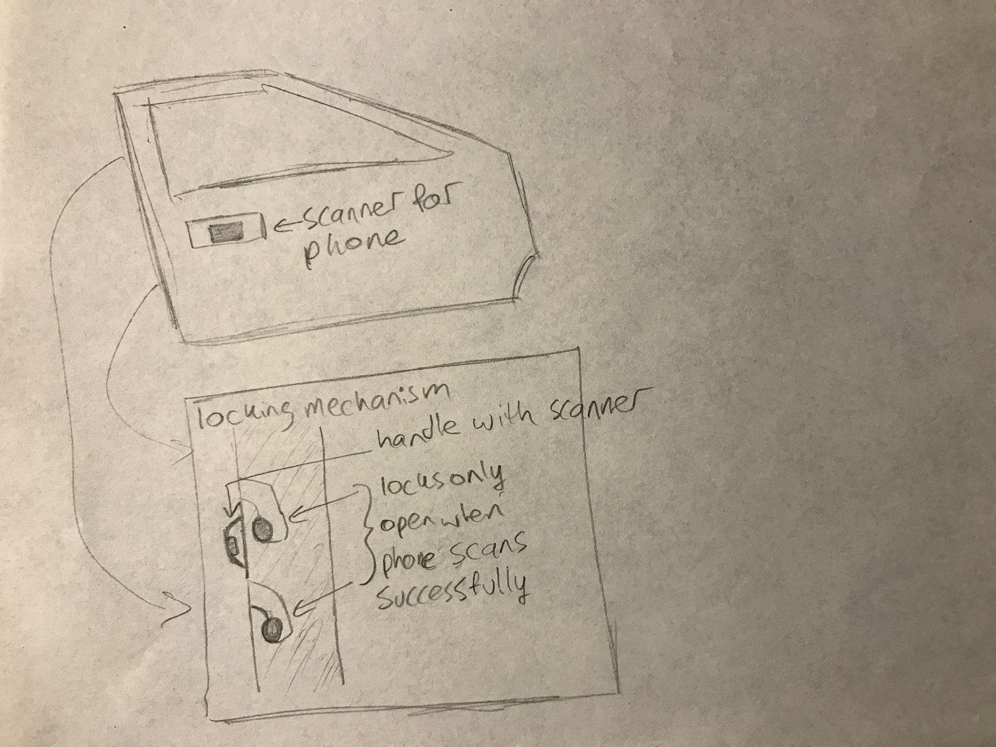

Figure 2 (Iteration 1): sketch for contactless door and contactless pay

The first design for replaceable seats were also installed, they take the form of plastic coverings that envelope the seats, once a passenger leaves they can be taken off and replaced with new ones. They are designed to make sure that people do not have to worry about coming into contact with the germs or airborne particles from the previous customers. The replaceable seat is easy to remove and install after each passenger has left or entered. The cylinder containing the plastic material will be on the ceiling of the car, with the push of a button, on the drivers control panel, the cylinder will roll out enough plastic to cover the seat. Then air suction tubes installed in the seat will suck the plastic cover to make it airtight. This is part of the comfortability we offer so that when you sit down there aren’t any air bubbles disturbing your travel. Removing the seat is also an easy task, when a passenger leaves the taxi taking her belongings with her the air suction tubes release the pressure they previously had been exerting and allow the plastic cover to be easily removed. Then the used plastic cover is discarded via a robotic arm and is placed in a trash compartment under the driver seat which is capable of holding more than two hundred used plastic covers. It’s advised that the driver empty the trash compartment every day.

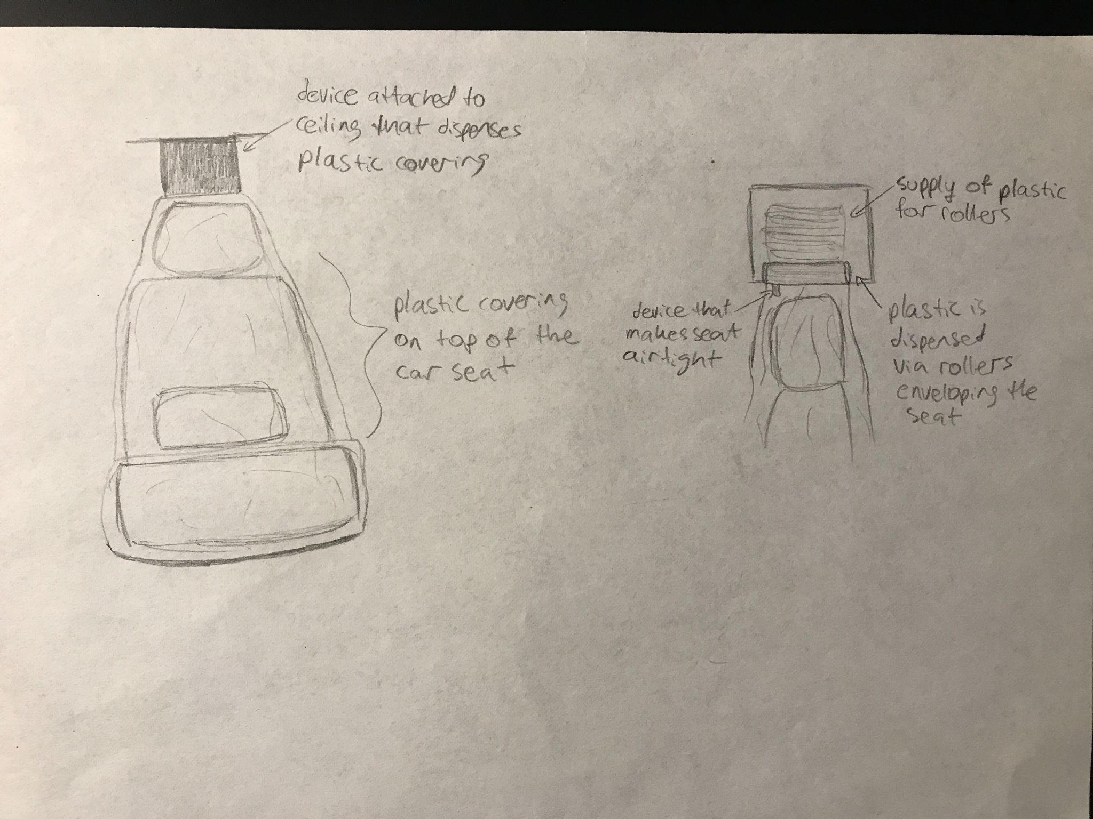

Figure 3 (Iteration 1): sketch for plastic replaceable seats

The first design of the passenger shield was also installed, which took the form of a clear vinyl pane separating the driver from the passenger. This ensures that airborne germs cannot be spread between the passenger and the driver. Even though there is a barrier between the driver and passenger the clear vinyl pane still allows eye contact. This pane does not have any holes in them due to the risk of airborne contaminants. Therefore, verbal communication is conducted through intercom receptors and receivers which intake the audio from one side of the pane to the other side via the speakers in the car. The clear vinyl pane is located between the driver and passenger seat on the front of the car and one between the passenger seats on the back of the car and the driver’s seat. This creates a sort of bubble around the driver protecting him and the passenger. It’s recommended that passengers use the back seats first before filling the front seat.

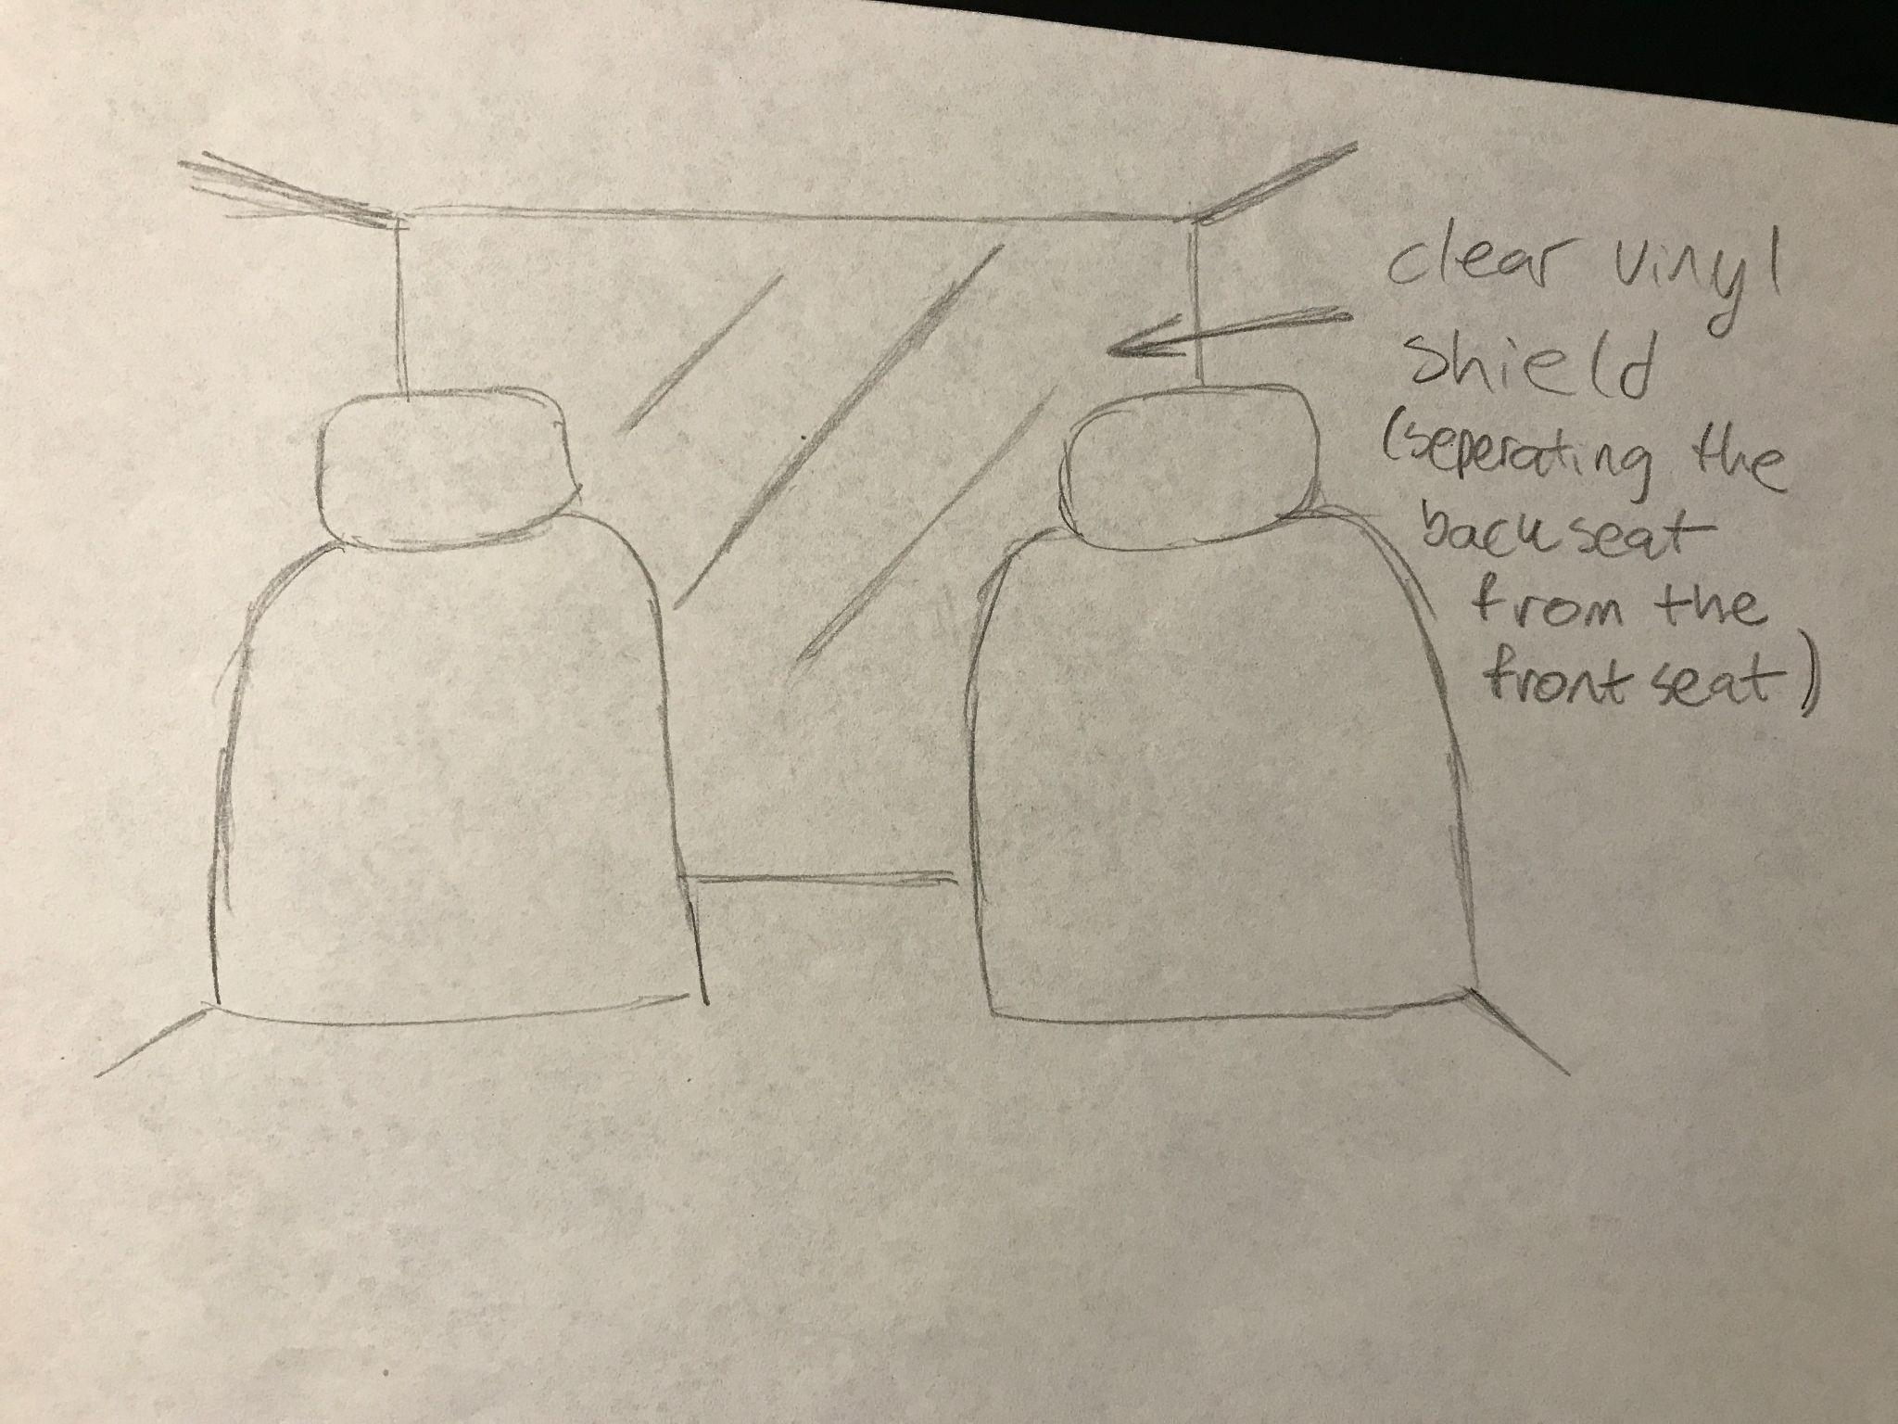

Figure 4 (Iteration 1): Clear vinyl passenger-driver shield

Finally we also installed a highly sophisticated device that uses Ultraviolet light to disinfect all surfaces in the vehicle from Covid-19. Based on research done by the U.S. Food & Drug administration we found that UV light can be used to disinfect surfaces of Covid. This cleaning process is meant to be conducted while there are no passengers and the driver is idle or traveling to pick up a passenger. This saves time and allows for a more efficient system. We estimate that the disinfection process should take no longer than four minutes and during this time under no circumstances are new passengers allowed in. Also at the end of the cab drivers shift the driver's seat is also disinfected to allow other drivers to drive that car on their shift. We understand the risks of UV light and it’s cause of cancer but we have taken the proper safety measures to make sure that the UV light is never in presence or in direct contact with a human being. Even when the passenger seats are being disinfected the driver will never be in any danger or exposure due to our safety measures.

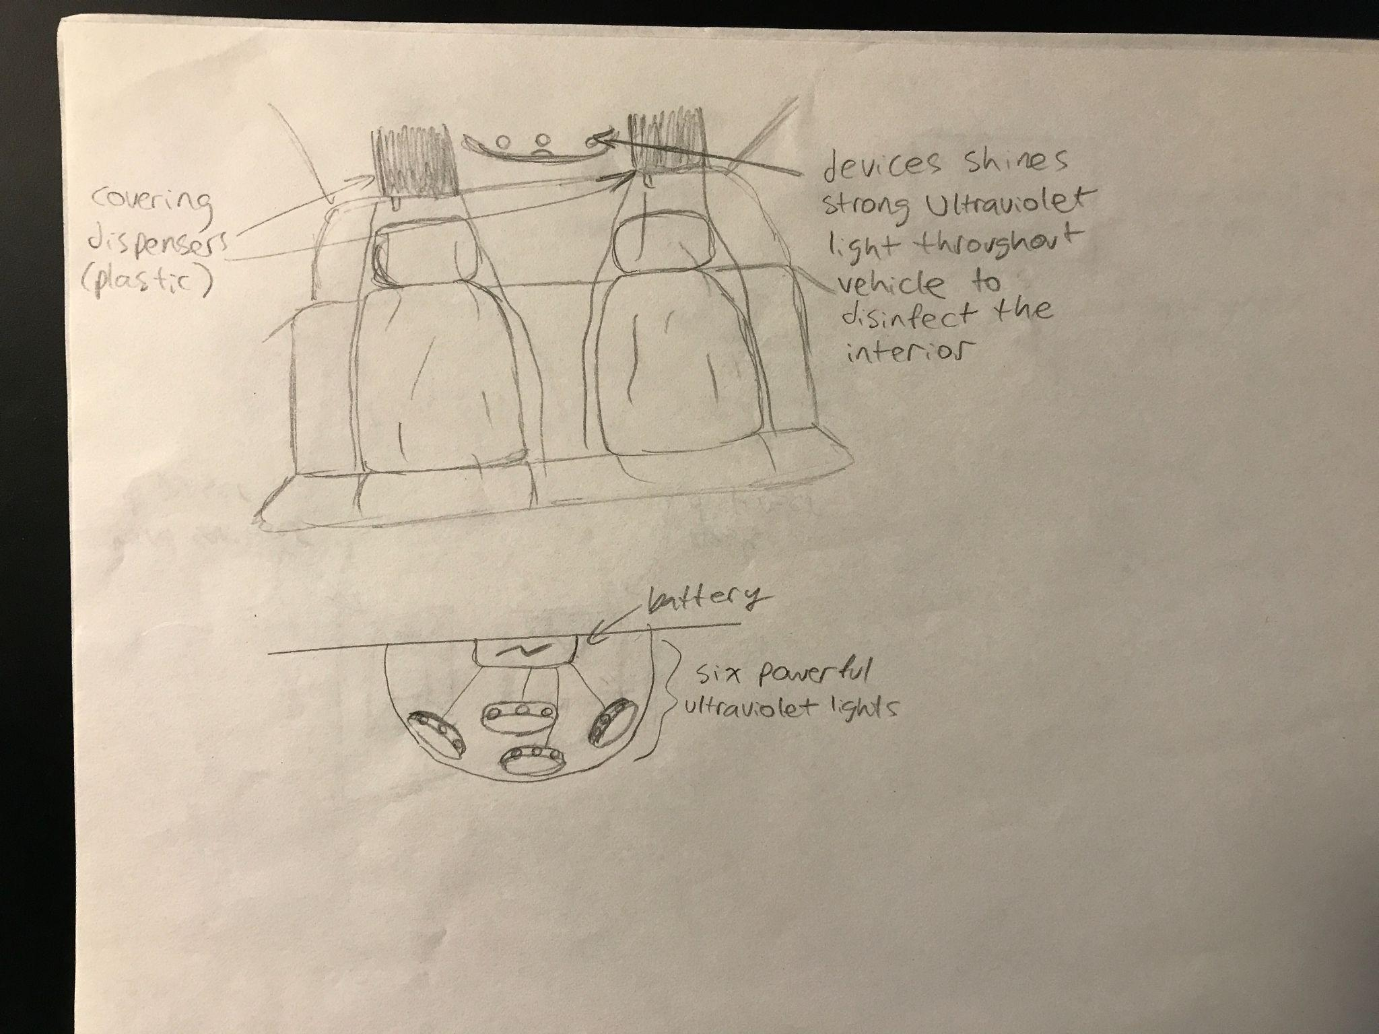

Figure 5 (Iteration 1): UVC radiation lamps for disinfecting seats

**Second Iteration**

The second iteration of our design looks to add new features to the taxi, while also expanding upon previous features introduced in the first iteration. The contactless pay and doors remain the same as the first iteration. Passengers are able to pay and submit their proof of vaccination through a mobile app, which eliminates the need for direct contact with the driver. The automatic doors allow entry into the vehicle through a sensor-activation system. Passengers simply have to wave their hand in front of the door for it to open. The barcode scanner on the car door still checks for the same criteria listed in our first iteration. The Ultraviolet light device also remains unchanged and reprises its role as a disinfectant for all the major surfaces of the car when no passengers are present. Customers are still required to complete a self screening test before entering the vehicle.

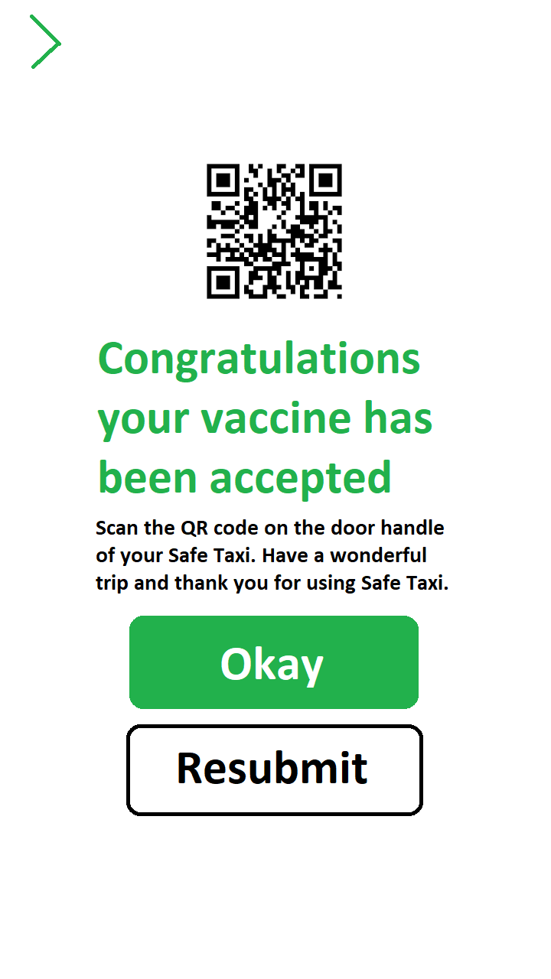

Figure 6 (Iteration 2): Mock-up design for app

This iteration improves upon the replaceable seats idea presented in the first iteration. The mechanism for which the seat covers get replaced remains the same; however, instead of plastic, the seat coverings are now made of thin, disposable paper as seen in Figure x. This change allows the taxi to utilize a more affordable material without ruining the intended function of the original material. We understand that switching the material could result in the cover becoming less durable; however, paper is recyclable, making it a greener and more sustainable alternative. Thus, it was found to be a nice compromise between durability and sustainability.

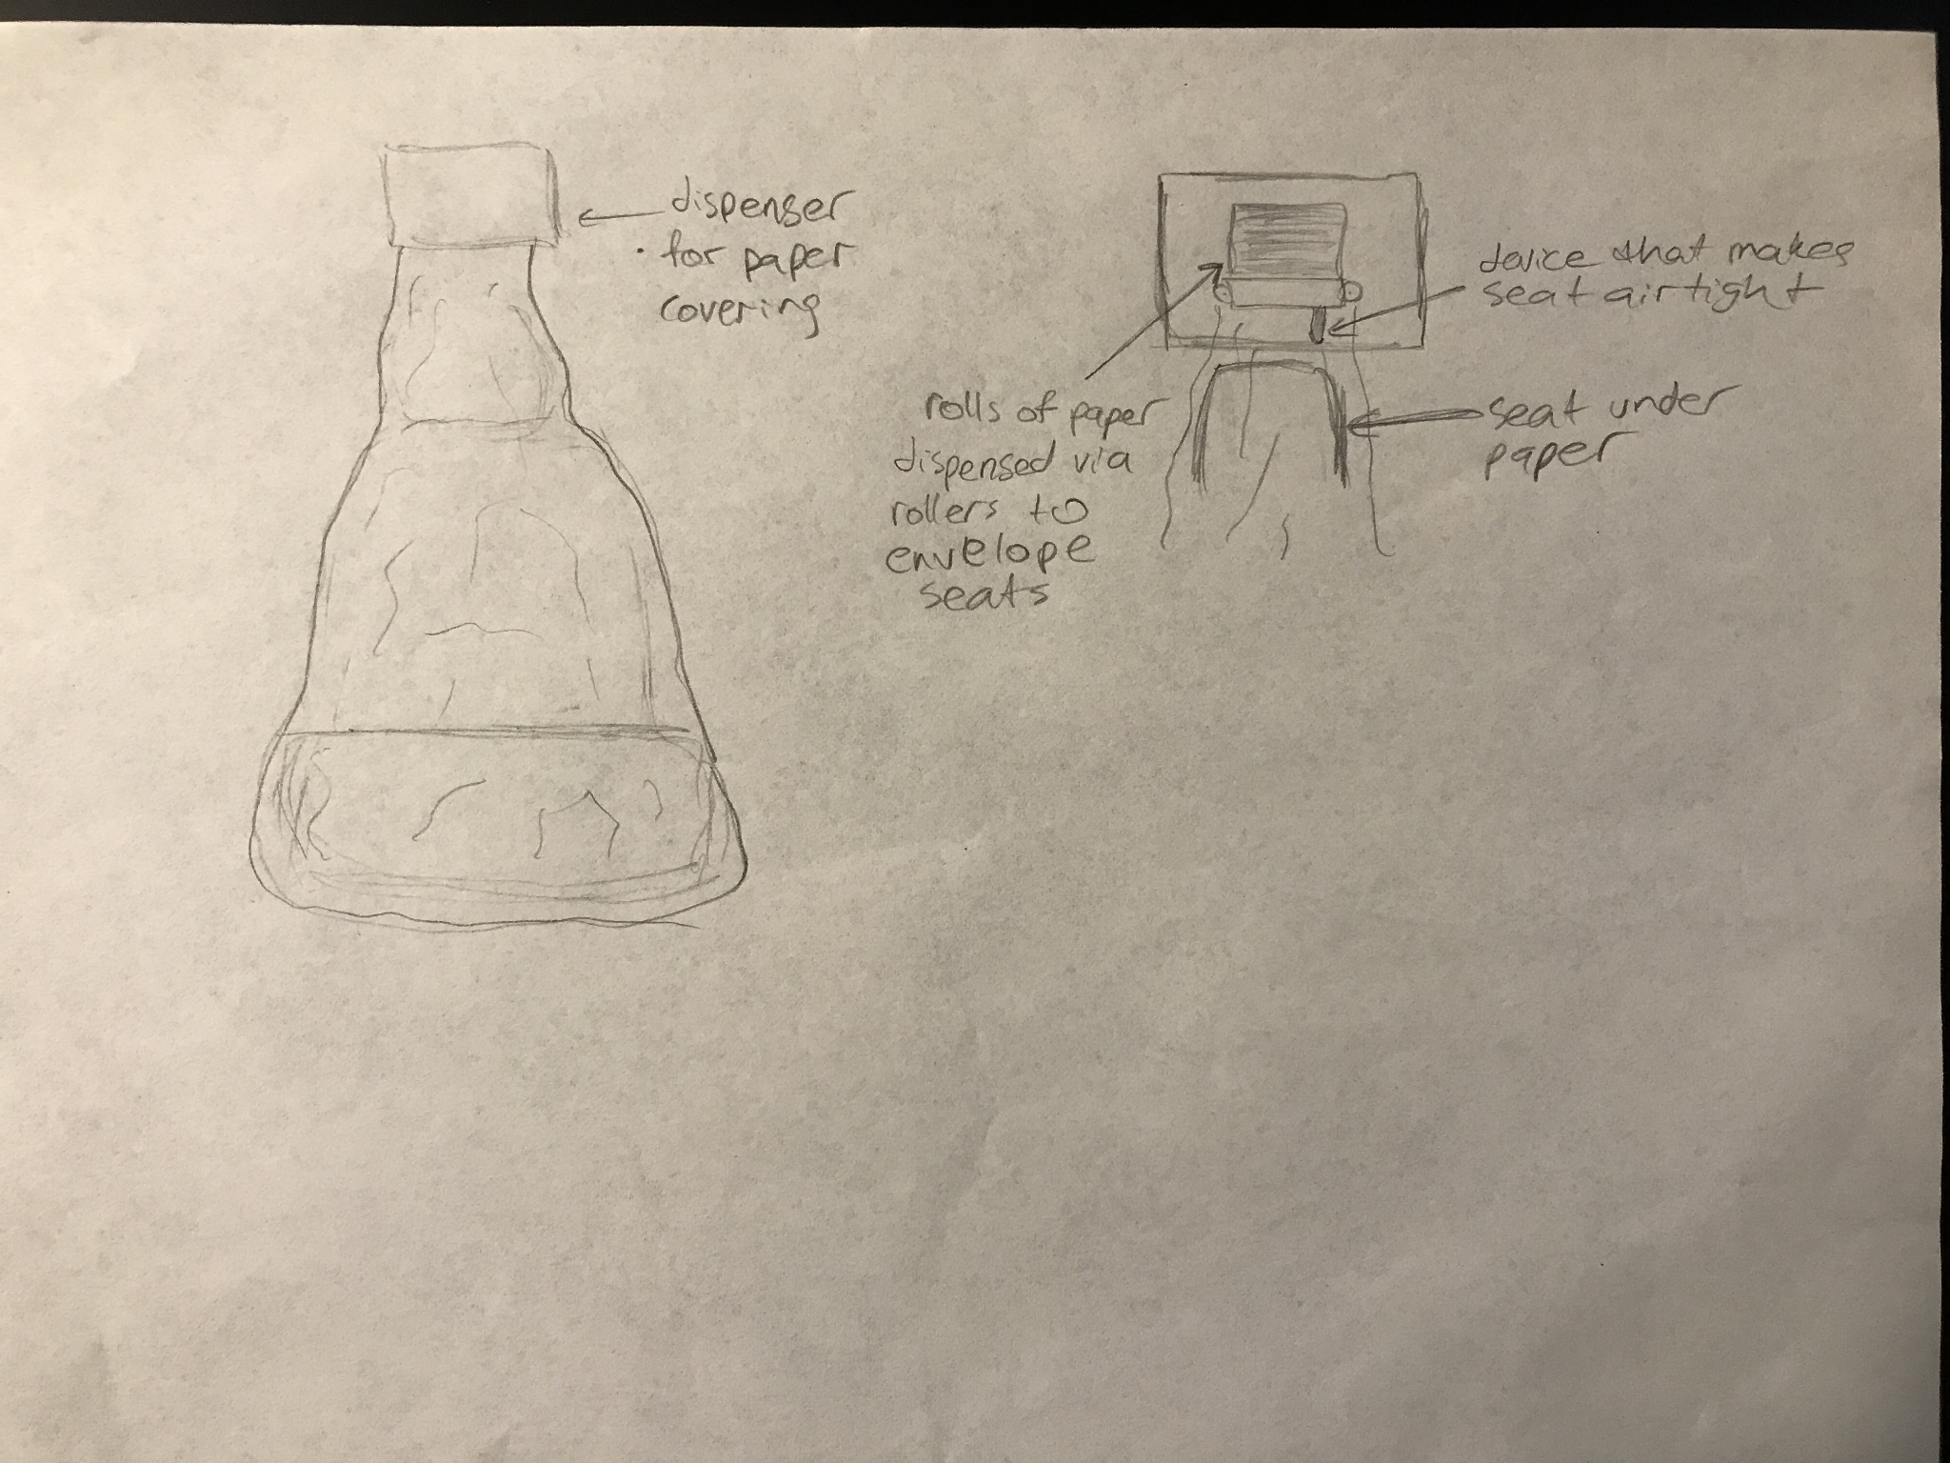

Figure 7 (Iteration 2): Paper seat covering sketch

We also implemented our second design of the passenger shield, as seen in Figure x. This time, we decided to switch the material of the shield to polycarbonate. Polycarbonate is a type of thermoplastic that also contains carbonate groups within their chemical structure. It is a highly versatile material, with many uses due to its extremely tough nature and abnormally high impact resistance. It is a common material used for Covid barriers, and when used in conjunction with face masks, proves effective in blocking airborne particles and droplets [9]. Thus, polycarbonate maintains all of the advantages of clear vinyl, while being a much stronger material. In the case of a car accident, the material also does not shatter, which is good for the well-being of both the driver and passengers.

Furthermore, the shield now includes a microphone which allows for better communication between passengers and the driver, as seen in Figure x. Having a large barrier between the driver and customers with no holes could lead to some issues regarding communication. Therefore, we’ve implemented the microphone system to alleviate that issue. Each side of the polycarbonate shield contains both a microphone and speaker. Passengers and drivers would be able to speak directly into their mics and have their messages be transmitted through the speakers on the other side. The result is a two-way communication system in which both the passengers and driver can clearly hear each other.

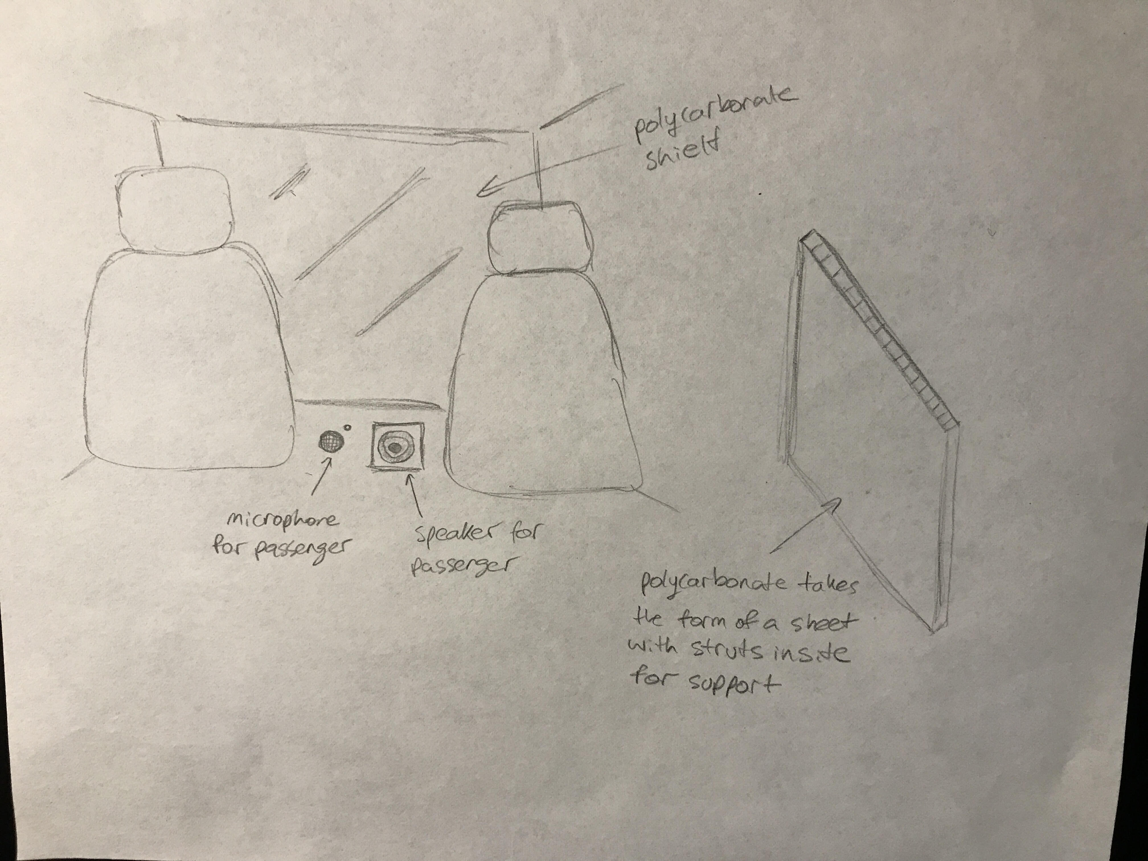

Figure 8 (Iteration 2): Speaker system & passenger shield

**Third Iteration**

The primary focus of the third iteration is to further optimize the devices and functions already present in the vehicle, whilst also adding some new functionality as well. The first addition is the introduction of the what the design team is referring to as the “Amalgamation Device” which serves the purpose of making the contactless door, the temperature sensor, and vaccine check into one device, reducing the complexity of the devices in the vehicle, and making the user experience more convenient. The passengers would have to scan their vaccination status QR code and check their temperature before being allowed to enter the vehicle.

Another introduction is the new sophisticated dual ventilation system, it essentially makes it so that there are two ventilation systems in the vehicle, one for the driver and one for the passengers, this allows for the air that the passenger breathes to be separate from the air that the driver breathes subsequently reducing the chances of the virus being spread through the air.

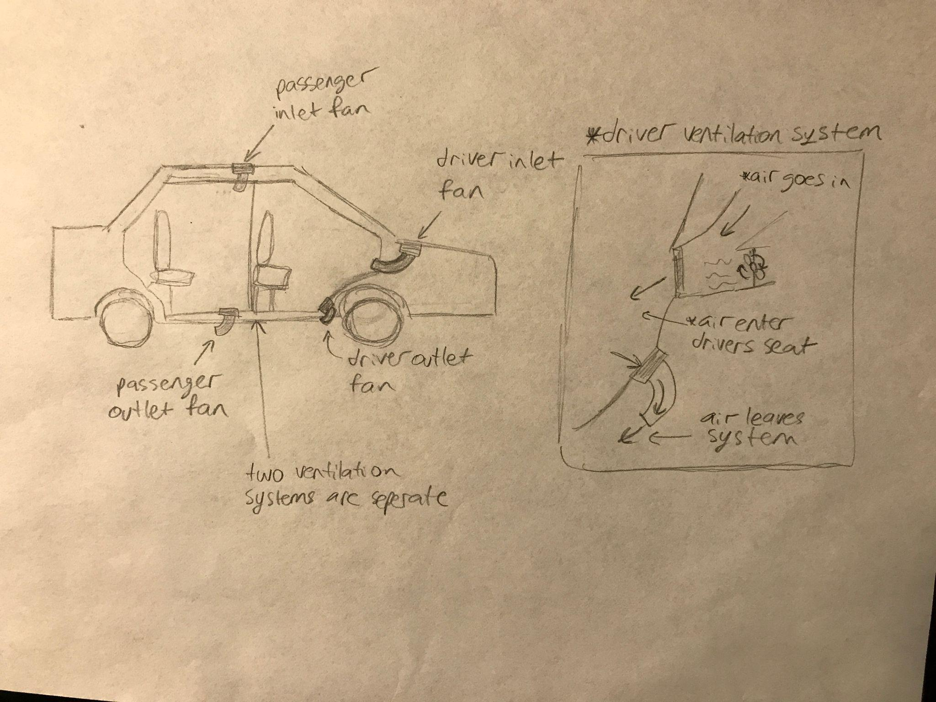

Figure 9 (Iteration 3): Dual ventilation system design

One final device being added is the dispenser for Covid-19 friendly items. It simply is a device that can provide riders of the taxi with handsanitizer and masks if they need it. This is simply here to ensure people can disinfect themselves when they enter the vehicle as well as get a mask if perhaps they forgot to bring one. It is also built into the vehicle in order to prevent theft.

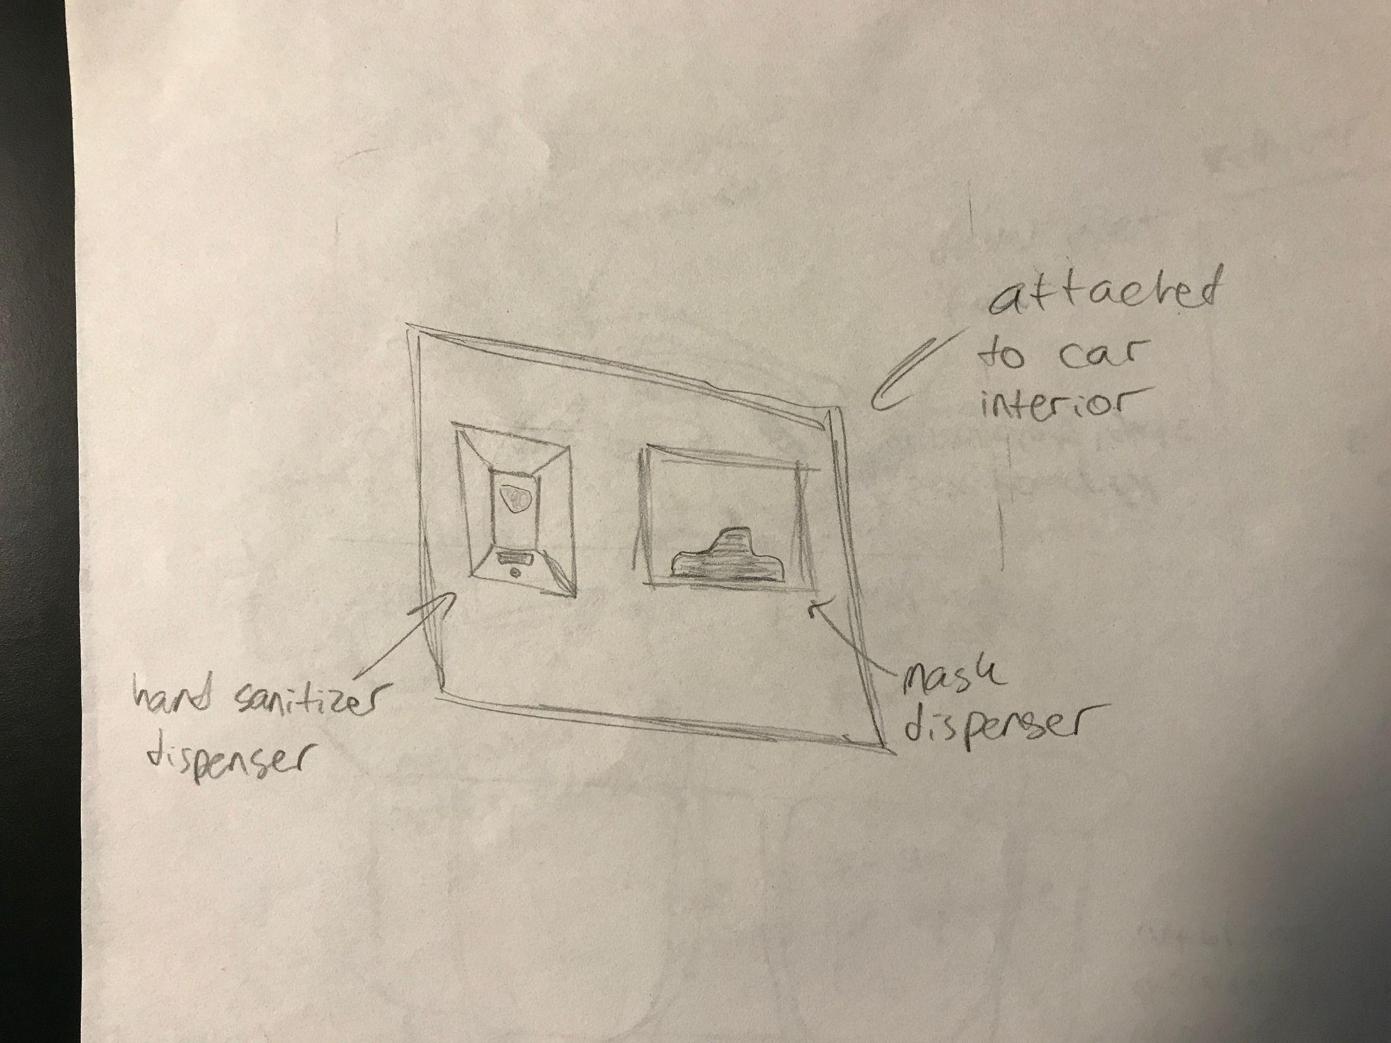

Figure 10 (Iteration 3): Hand sanitizer and mask dispenser

**Marketing**

The “Safe Taxi” is a product for the average commuter, pedestrian, and tourist. The

similarity between these groups of people is that the majority of them are millennials. Pedestrians in metropolitan areas tend to be commuters as well and Statistics Canada reported that by 2020 50% of the workforce will consist of millennials and millennials are famous for their use of social media. ​​The best way to communicate to these people is through social media, particularly, Instagram. However, there are disadvantages of only focusing on a certain age demographic so the ads will be advertised in newspapers to catch the attention of seniors who still use transportation services. Of course, like many companies with prototypes, this invention is not intended to go national or international yet. For now the focus will be specifically the difference that can be made in one city and that city is Toronto, Canada. Toronto Star and 6ixbuzz are the leaders in the newspaper and social media industry respectively. Not only will it be advertised on Uber’s social media company account but also advertisements on Toronto’s favourite instagram account 6ixbuzz.

The following advertisement was designed to catch the eyes of individuals who use public transportation on a regular basis (geared towards mostly young adults and seniors). The advertisement highlights the new and improved Uber’s advantages and steps taken by the ridesharing companies against Covid-19. The outcome of this endeavour is crucial in determining future sponsors, partnerships, and how big this product can get. This marketing scheme will surely catch the attention of many future passengers who themselves might reference it to their colleagues. The goal of this special service is to truly give you your money's worth in hospitality, comfortability, and safety especially during the pandemic.

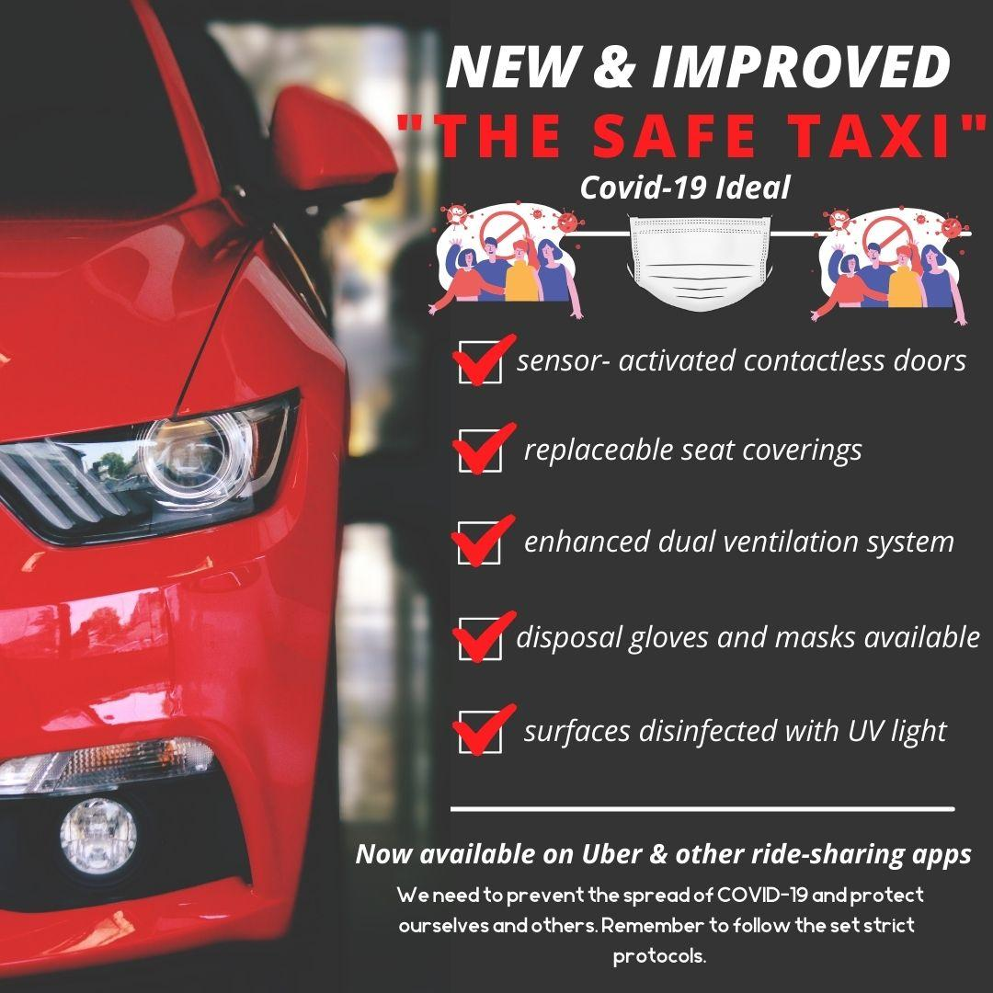

Figure 11: Advertisement for “Safe Taxi”

**Conclusion**

In conclusion, Covid-19 is a serious threat and it requires people of all facets of life no matter how seemingly small that facet may be to be involved. This includes taxis, being something that thousands of people across the country require on a daily basis, it is clear that it is essential that taxis evolve and change in order to fit in with this new normal. This report hopefully showed you that the Safe Taxi can be that change and simply by adding new features and devices to the already existing taxi it absolutely can help in reducing the spread of Covid-19 as well giving people the confidence to use Taxis again.

**References**

[1] “Evidence for transmission of SARS-COV-2 on ground public ...” [Online]. Available: https://assets.publishing.service.gov.uk/government/uploads/system/uploads/attachment_data/file/904663/S0441_EMG_-_Evidence_for_transmission_of_SARS-COV-2_on_ground_public_transport.pdf. [Accessed: 17-Nov-2021].

[2] “Public transport and covid-19 – what we know so far.” [Online]. Available: https://www.publichealthontario.ca/-/media/documents/ncov/covid-wwksf/2020/12/what-we-know-covid-public-transport.pdf?la=en. [Accessed: 17-Nov-2021].

[3]H. Baskas, “Dirty driving: Ride-hailing services worst culprits for germs, study says,” *CNBC*, 21-May-2016. [Online]. Available:https://www.cnbc.com/2016/05/19/dirty-driving-ride hailing-services-worst-culprits-for-germs-study-says.html. [Accessed: 23-Nov-2021].

[4]K. Budd, “How long do cars last? A guide to your car's longevity,” *AARP*, 01-Nov-2018. [Online]. Available: https://www.aarp.org/auto/trends-lifestyle/info-2018/how-long-do-cars-last.html. [Accessed: 24-Nov-2021].

[5]2014 Taxicab Factbook. [Online]. Available: https://www1.nyc.gov/assets/tlc/downloads/pdf/2014_tlc_factbook.pdf . [Accessed: 24-Nov-2021].

[6]Published by Statista Research Department and N. 4, “U.S. taxi cabs usage frequency 2018,” *Statista*, 04-Nov-2020. [Online]. Available: https://www.statista.com/statistics/936422/taxi-cab-usage-frequency-united-states/. [Accessed: 24-Nov-2021].

[7]R. LeBlanc, “An Overview of Auto Recycling,” *The Balance Small Business*, 07-Aug-2019. [Online]. Available: https://www.thebalancesmb.com/how-are-cars-recycled-2877944#:~:text=Almost all the parts of,, oil filters, and mats. [Accessed: 24-Nov-2021].

[8]W. Mackenzie, “Is Paper A More Sustainable Flexible Packaging Material Than Plastic?,” *Forbes*, 24-Aug-2020. [Online]. Available: https://www.forbes.com/sites/woodmackenzie/2020/08/24/is-paper-a-more-sustainable-flexible-packaging-material-than-plastic/#:~:text=Paper is far more biodegradable,the same weight of plastic. [Accessed: 24-Nov-2021].

[9]J. L. Cadnum, A. L. Jencson, and C. J. Donskey, “Do plexiglass barriers reduce the risk for transmission of severe acute respiratory syndrome coronavirus 2 (SARS-CoV-2)?,” *Cambridge University Press*, 02-Nov-2021. [Online]. Available: https://www-cambridge-org.ezproxy.lib.ryerson.ca/core/journals/infection-control-and-hospital-epidemiology/article/do-plexiglass-barriers-reduce-the-risk-for-transmission-of-severe-acute-respiratory-syndrome-coronavirus-2-sarscov2/F8F904A5983B114F49D0A6D525ADEB9F. [Accessed: 24-Nov-2021].

[10]M. Buonanno, D. Welch, I. Shuryak, and D. J. Brenner, “Far-UVC light (222 nm) efficiently and safely inactivates airborne human coronaviruses,” *Scientific reports*, 24-Jun-2020. [Online]. Available: https://www.ncbi.nlm.nih.gov/pmc/articles/PMC7314750/. [Accessed: 24-Nov-2021].

[11]“taxicab,” *Encyclopædia Britannica*. [Online]. Available: https://www.britannica.com/technology/taxicab. [Accessed: 24-Nov-2021].

[12]“Uber Revenue and Usage Statistics (2021),” *Business of Apps*, 12-Nov-2021. [Online]. Available: https://www.businessofapps.com/data/uber-statistics/. [Accessed: 24-Nov-2021].

[13]“The History of Uber - Ubers Timeline,” *Uber Newsroom*, 02-May-2018. [Online]. Available: https://www.uber.com/en-CA/newsroom/history/. [Accessed: 24-Nov-2021].

[14]“What is Polycarbonate?,” *Polycarbonate Facts - A&C Plastics*. [Online]. Available: https://www.acplasticsinc.com/informationcenter/r/what-is-polycarbonate. [Accessed: 24-Nov-2021].

[15]City of Toronto, “COVID-19 Guidance: Taxis & Ride Shares,” *City of Toronto*, 27-Oct-2021. [Online]. Available: https://www.toronto.ca/home/covid-19/covid-19-reopening-recovery-rebuild/covid-19-reopening-guidelines-for-businesses-organizations/covid-19-guidance-taxis-ride-shares/. [Accessed: 24-Nov-2021].

[16]“COVID-19 Guidance for Taxi Services and Ride Sharing Vehicles: EOHU: Public Health,” *EOHU*. [Online]. Available: https://eohu.ca/en/covid/covid-19-guidance-for-taxi-services-and-ride-sharing-vehicles. [Accessed: 24-Nov-2021].

[17]“Build and Price,” *Toyota Canada*. [Online]. Available: https://www.toyota.ca/toyota/en/build-price. [Accessed: 24-Nov-2021].

[28]“40 gauge clear vinyl,” *OnlineFabricStore*. [Online]. Available: https://www.onlinefabricstore.com/40-gauge-clear-vinyl-.htm. [Accessed: 24-Nov-2021].

[19]“Square Reader Apple Pay and Chip Cards,” *Apple (CA)*. [Online]. Available: https://www.apple.com/ca/shop/product/HJCU2VC/B/square-reader-apple-pay-and-chip-cards. [Accessed: 24-Nov-2021].

[20]“MLX90614ESF-BCC-000-TU in Tube by Melexis: Temperature Sensors: Future Electronics,” *MLX90614ESF-BCC-000-TU in Tube by Melexis | Temperature Sensors | Future Electronics*. [Online]. Available: https://www.futureelectronics.com/p/semiconductors--analog--sensors--temperature/mlx90614esf-bcc-000-tu-melexis-2532877?gclid=CjwKCAiAv_KMBhAzEiwAs-rX1IZZ6yfkIuEuA1bgTCzKcGx8X1h7Yo-t3dO6TBrVS2oc-IHa5zyH6hoCAkgQAvD_BwE. [Accessed: 24-Nov-2021].

[21]*SparkFun 2D Barcode Scanner Breakout.* [Online]. Available: <https://www.robotshop.com/ca/en/sparkfun-2d-barcode-scanner-breakout.html?gclid=CjwKCAiAv_KMBhAzEiwAs-rX1CV-zgfOVbSygm2ZcT2Gad3lDmQMdsRUTxl5rEvj7qFMK4r-GASUSxoCclYQAvD_BwE>. [Accessed: 24-Nov-2021].

[22]*Far-Uvc 222Nm Far Led Lamp Grow Light Uv Ir Portable Manufacturer Linear Ultraviolet Sterilizer*. [Online]. Available: https://www.alibaba.com/pla/Far-uvc-222nm-far-uvc-led-lamp_1600079221225.html?mark=google_shopping&biz=pla&pcy=CA&searchText=Far-Uvc 222Nm&src=sem_ggl&from=sem_ggl&cmpgn=13643151963&adgrp=122868057726&fditm=&tgt=pla-294505072980&locintrst=&locphyscl=9000932&mtchtyp=&ntwrk=u&device=c&dvcmdl=&creative=529690454129&plcmnt=&plcmntcat=&p1=&p2=&aceid=&position=&localKeyword=&pla_prdid=1600079221225_damos&pla_country=CA&pla_lang=en&gclid=CjwKCAiAv_KMBhAzEiwAs-rX1Nr27oGMhWm0Erb9cn_p0Eymp5ljZt_ZO5bK3XgK4N2fDt_fbmwJFxoC9IYQAvD_BwE. [Accessed: 24-Nov-2021].

[23]“Cellophane wrap 30‘X100' roll-clear: Walmart Canada,” *Walmart.ca*. [Online]. Available: https://www.walmart.ca/en/ip/Cellophane-Wrap-30-X100-Roll-Clear/PRD5PFN8FL7DCBK. [Accessed: 24-Nov-2021].

[24]“NEMA 23 Integrated Easy Servo Motor 90w 3000rpm 0.3Nm(42.49oz.in) 20-50VDC Brushless DC Servo Motor,” *STEPPERONLINE*. [Online]. Available: https://www.omc-stepperonline.com/nema-23-integrated-easy-servo-motor-90w-3000rpm-0-3nm-42-49oz-in-20-50vdc-brushless-dc-servo-motor.html. [Accessed: 24-Nov-2021].

[25]*Medical Exam Table Paper-Extra Wide- 24" width 125 feet long 12 roll per Case - Crepe*. [Online]. Available: https://www.mywellcare.ca/index.php?route=product/product&product_id=2160. [Accessed: 24-Nov-2021].

[26]*Solid Polycarbonate Sheet Pricing*. [Online]. Available: https://lexanpolycarbonate.com/solid_polycarbonate_sheet.html. [Accessed: 24-Nov-2021].

[27]*Customized Low Resistance Air Purifier Hepa Replacement Parts Filter H13 With Small Ears - Buy High Filtration Air Purifier Filter Parts,Air Hepa Purifier Filters Spare Parts,High Efficiency Hepa Purifier Filter Product on Alibaba.com*. [Online]. Available: https://www.alibaba.com/product-detail/Hepa-Filter-Hepa-Filter-Replacement-Customized_1600188855706.html?spm=a2700.7724857.topad_classic.d_title.258e6a3cYeDnT3. [Accessed: 24-Nov-2021].

[28]*shop.projectn95.org*. [Online]. Available: https://shop.projectn95.org/astm-level-3-byd-surgical-masks-box-of-50/p. [Accessed: 24-Nov-2021].

[29]“Uline Industrial Nitrile Gloves - Powder-Free, 4 Mil, Medium S-14179M,” *Uline*. [Online]. Available: https://www.uline.ca/Product/Detail/S-14179M/Nitrile-Gloves/Uline-Industrial-Nitrile-Gloves-Powder-Free-4-Mil-Medium?pricode=YE313&gadtype=pla&id=S-14179M&gclid=CjwKCAiAv_KMBhAzEiwAs-rX1G7vJlWl29RYNbEFqUWcaMvN-hshDHCigOu8V2xWg8Z8Sr4IzKCBthoCiN4QAvD_BwE&gclsrc=aw.ds. [Accessed: 24-Nov-2021].

[30]Center for Devices and Radiological Health, “UV Lights and Lamps: Ultraviolet-C Radiation, Disinfection, and Corona,” *U.S. Food and Drug Administration*. [Online]. Available: https://www.fda.gov/medical-devices/coronavirus-covid-19-and-medical-devices/uv-lights-and-lamps-ultraviolet-c-radiation-disinfection-and-coronavirus. [Accessed: 24-Nov-2021].

[31]“NIOSHTIC-2 Publications Search - 20034387 - Ultraviolet germicidal irradiation - current best practices.,” *Centers for Disease Control and Prevention*, 02-Sep-2020. [Online]. Available: https://www.cdc.gov/niosh/nioshtic-2/20034387.html. [Accessed: 24-Nov-2021].